JumpTo  
 A Favorites Tool for Unity, from Imp Rock

JumpTo is designed to fit into the standard Unity workflow, so it should feel fairly native to the Unity Editor. Simply drag and drop GameObjects and assets from your project to the JumpTo window to create handy shortcuts.

## Where JumpTo Lives

|  |  |
| --- | --- |
|  | Within the ImpRock folder is a subfolder for JumpTo. This is where it lives. If you prefer, it can safely be moved to another folder in your project. Just know that, if moved, any future updates may not install properly. |

## Open the JumpTo Window

|  |  |
| --- | --- |
| C:\Users\dean\AppData\Local\Microsoft\Windows\INetCache\Content.Word\jumpto20_launchmenuitem.png | Go to Unity’s menu bar at the top. Inside the *Window* menu is the *JumpTo* menu item. Select it to open JumpTo. |

## The JumpTo Window

|  |  |
| --- | --- |
| C:\Users\dean\AppData\Local\Microsoft\Windows\INetCache\Content.Word\jumpto20_emptywindow.png | Introducing JumpTo v2.0! When JumpTo is empty, it provides some friendly information to help get you started.  An important detail noted here is that Hierarchy links **must** be saved manually, whereas Project links will save automatically. This is due to some technical limitations within the Unity Editor. |

## Creating Links to Objects and Assets

### Via Drag & Drop

Select GameObjects within the Hierarchy window, or select assets within the Project window, *or both*. Then, drag the selection to JumpTo, and drop. Links to the selected items will be created.

### Via Menu Items

There are alternatives to drag & drop. Use the *Create* menus found in the Hierarchy and Project windows, and select *JumpTo Link*. You can also use the *GameObject* menu found in Unity’s menu bar, and select *JumpTo Link* there. Finally, if you context-click a scene object, then select *JumpTo Link* from the popup menu. All four will create links to whatever is currently selected.

Note that JumpTo will ignore items that already have links.

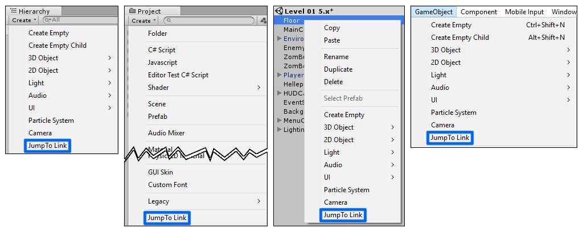

## The JumpTo Window

|  |  |
| --- | --- |
| C:\Users\dean\AppData\Local\Microsoft\Windows\INetCache\Content.Word\jumpto20_links.png | Links are separated into *views*. Each view is collapsible by clicking its title bar. The C:\Users\dean\AppData\Local\Microsoft\Windows\INetCache\Content.Word\hamburger.png button on the right side of the view title bar pops up a menu with options for selecting links as well as removing all links from that view.  The *Project Links* view will be open only when links to assets are present. This view is always on top.  Scene object links will be in a view that corresponds to that scene. Click the button, if present, to save links to a file.  Notice that link titles have different colors. These all follow the Unity standard, except for the title of a model link. The title color for model links is violet to distinguish them from prefab links. Something that Unity does not do in the hierarchy. |

## Arranging Links

|  |  |
| --- | --- |
| C:\Users\dean\AppData\Local\Microsoft\Windows\INetCache\Content.Word\jumpto20_rearrangelinks.png | Drag Links within their view to arrange them as needed. The familiar blue line will show up to indicate where it will drop.  Link order will be maintained when restored from file. Links can be rearranged in whatever order you like. When coupled with the fancy selection options, this can be handy for speeding up your workflow. |

## Selecting Links

Selecting links also sets the selection for the Unity Editor. If JumpTo has a link to an object or asset, when that object or asset is selected from the Hierarchy or Project windows, it will also be selected in JumpTo.

Single clicking a link will set that item as the current selection.

Items can be multi-selected using the Shift key for ranged selection, or the Ctrl key (Cmd for OSX) for individual items. Ctrl/Cmd clicking a link that is already selected will deselect that link.

The menu provides options for *Select All, Select Inverse,* and *Select None*. These operate only on the view to which the menu belongs. These options are only available when a view is expanded.



Ctrl+A (or Cmd+A for OSX) will select all visible links. Links in collapsed views will not be deselected.

## Working with Links

Links can be dragged to other Editor windows and behave just as they do when dragged from the Hierarchy or Project windows.

|  |  |
| --- | --- |
| C:\Users\dean\AppData\Local\Microsoft\Windows\INetCache\Content.Word\jumpto20_linkcontextmenu.png | Context-click one or more links to expose some more actions.  Linked objects can be “pinged” (Unity highlights it in yellow within its corresponding window). Links can also be removed. Assets can be opened, while GameObjects can be framed in the current Scene window. |

Double-clicking a link is the same as double-clicking an object or asset in the Hierarchy or Project windows. Assets will be opened for editing, and GameObjects will be framed in the current Scene window.

The Delete key (Cmd+Del for OSX) will delete the current link selection, but **not** the linked objects or assets themselves.

## Saving

This is the interesting part. Project Links are saved automatically when JumpTo is closed, after a code compile, and on scene save. However, Hierarchy Links must be saved manually. This is because the Unity Editor, sadly, does not provide enough information about what it is doing at any given moment.

**WARNING**: If links exist for objects within a scene, and that scene is closed or unloaded **before** the links are saved, then the links will be lost! See the Known Issues section.

Until the Unity Editor gives us more feedback about each step during the scene saving process, saving Hierarchy links will have to be manual.

Another thing to note is that objects that have not been saved within a scene have no unique identifiers. Therefore, JumpTo has nothing to look for when links for that scene are reloaded at a later time. These links will be lost. To avoid this, save your scene **before** saving the links.

Save files are plain text and get stored in a subfolder within your project’s root called *JumpTo*.

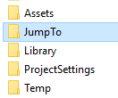

Within that folder…



…and within the *HierarchyLinks* folder…



…where the filename is the GUID of the scene asset to which it belongs.

Feel free to poke around in these save files, but be warned that they could become corrupt if edited directly.

## Loading

When the JumpTo window is opened, Project links, if previously saved, will automatically be loaded. JumpTo will also load links for any scenes that are currently loaded.

While the JumpTo window is open, loading and unloading, opening and closing scenes will also cause associated views to open and close. Again…

**WARNING**: If links exist for objects within a scene, and that scene is closed or unloaded **before** the links are saved, then the links will be lost!

## Known Issues

*Links to scene instances of prefab children can be broken.*  
Create a link to a child within a prefab. Save the Hierarchy view’s links to file. Close JumpTo. Move the child object to the scene root. Reopen JumpTo. The link will be missing. This is due to the way that Unity stores prefabs within a scene. Children of prefabs have no unique identifiers. JumpTo will do the best it can to locate the object on load, but if the object has been moved while JumpTo is closed, there is no way to distinguish it from any other object.

*Closing or unloading a scene will close the link view, and unsaved links will be lost*  
The Unity Editor typically will raise an event or set some flag to signal that an important thing has happened. But, sometimes, that is too late. It is not currently possible to detect that data in a particular scene is about to be unloaded. Therefore, JumpTo only knows that a scene has already unloaded, and since the scene data is gone at that point, there is nothing to save. This one may have a workaround in a future version.

## Contact Me

Preferably, most issues will be reported on the Unity forum thread. This is for the sake of posterity. Almost like a live, public, and preserved change log. However, if needed, you can email me directly at [dean@improck.com](mailto:dean@improck.com). Or, you can PM me on the Unity forums. My username is *thelackey3326*.

Thank you for choosing JumpTo!